### UML Diagrams

The Unified Modeling Language (UML) is a modeling language used by software developers. UML can be used to develop diagrams and provide users or program- mers with ready-to-use, expressive modeling examples. It is a way to visually represent the architecture, design, and implementation of complex software sys- tems.

#### Use Case Diagram

A use case diagram is a type of behavioral diagram in UML that represents the interactions between a system and its users or external systems. It depicts the vari- ous use cases or functionalities of a system and how they are connected to actors or stakeholders who interact with the system. The use case diagram typically includes use case ovals, actors represented by stick figures, and lines connecting them to show the interactions. Figure 5.2 depicts the use case diagram.These represent the relation between Administrator, Fieldworker, Sysytem, Image Component device.

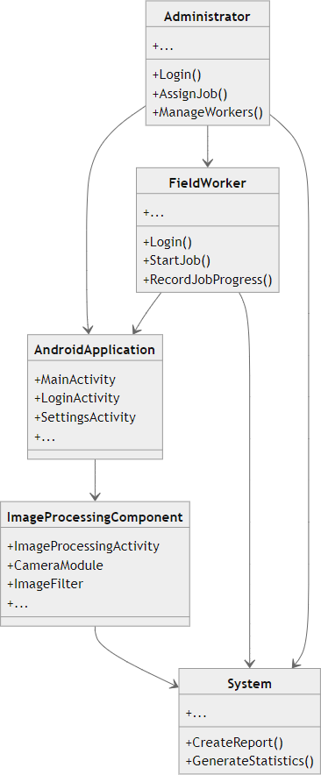

Figure 5.2: Use Case diagram of MGNREGA APP

Use Case diagram for workers and staff to explain about the application of the system.A use case diagram serves as a visual representation in software en- gineering, depicting how users (actors) interact with a system to achieve specific goals. Actors, represented as stick figures, denote individuals, external systems, or entities engaging with the system. Use cases, depicted as ovals, outline distinct functionalities or actions the system can perform to fulfill particular user needs.

#### Sequence Diagram

A sequence diagram in UML is a dynamic diagram that illustrates interactions between objects or components in a system over time. It represents the flow of messages, actions, and interactions among different elements, showcasing the sequence of events as they occur chronologically. It include the steps like:

1. To capture the image
2. Process pit Dimensions
3. Update data in the database

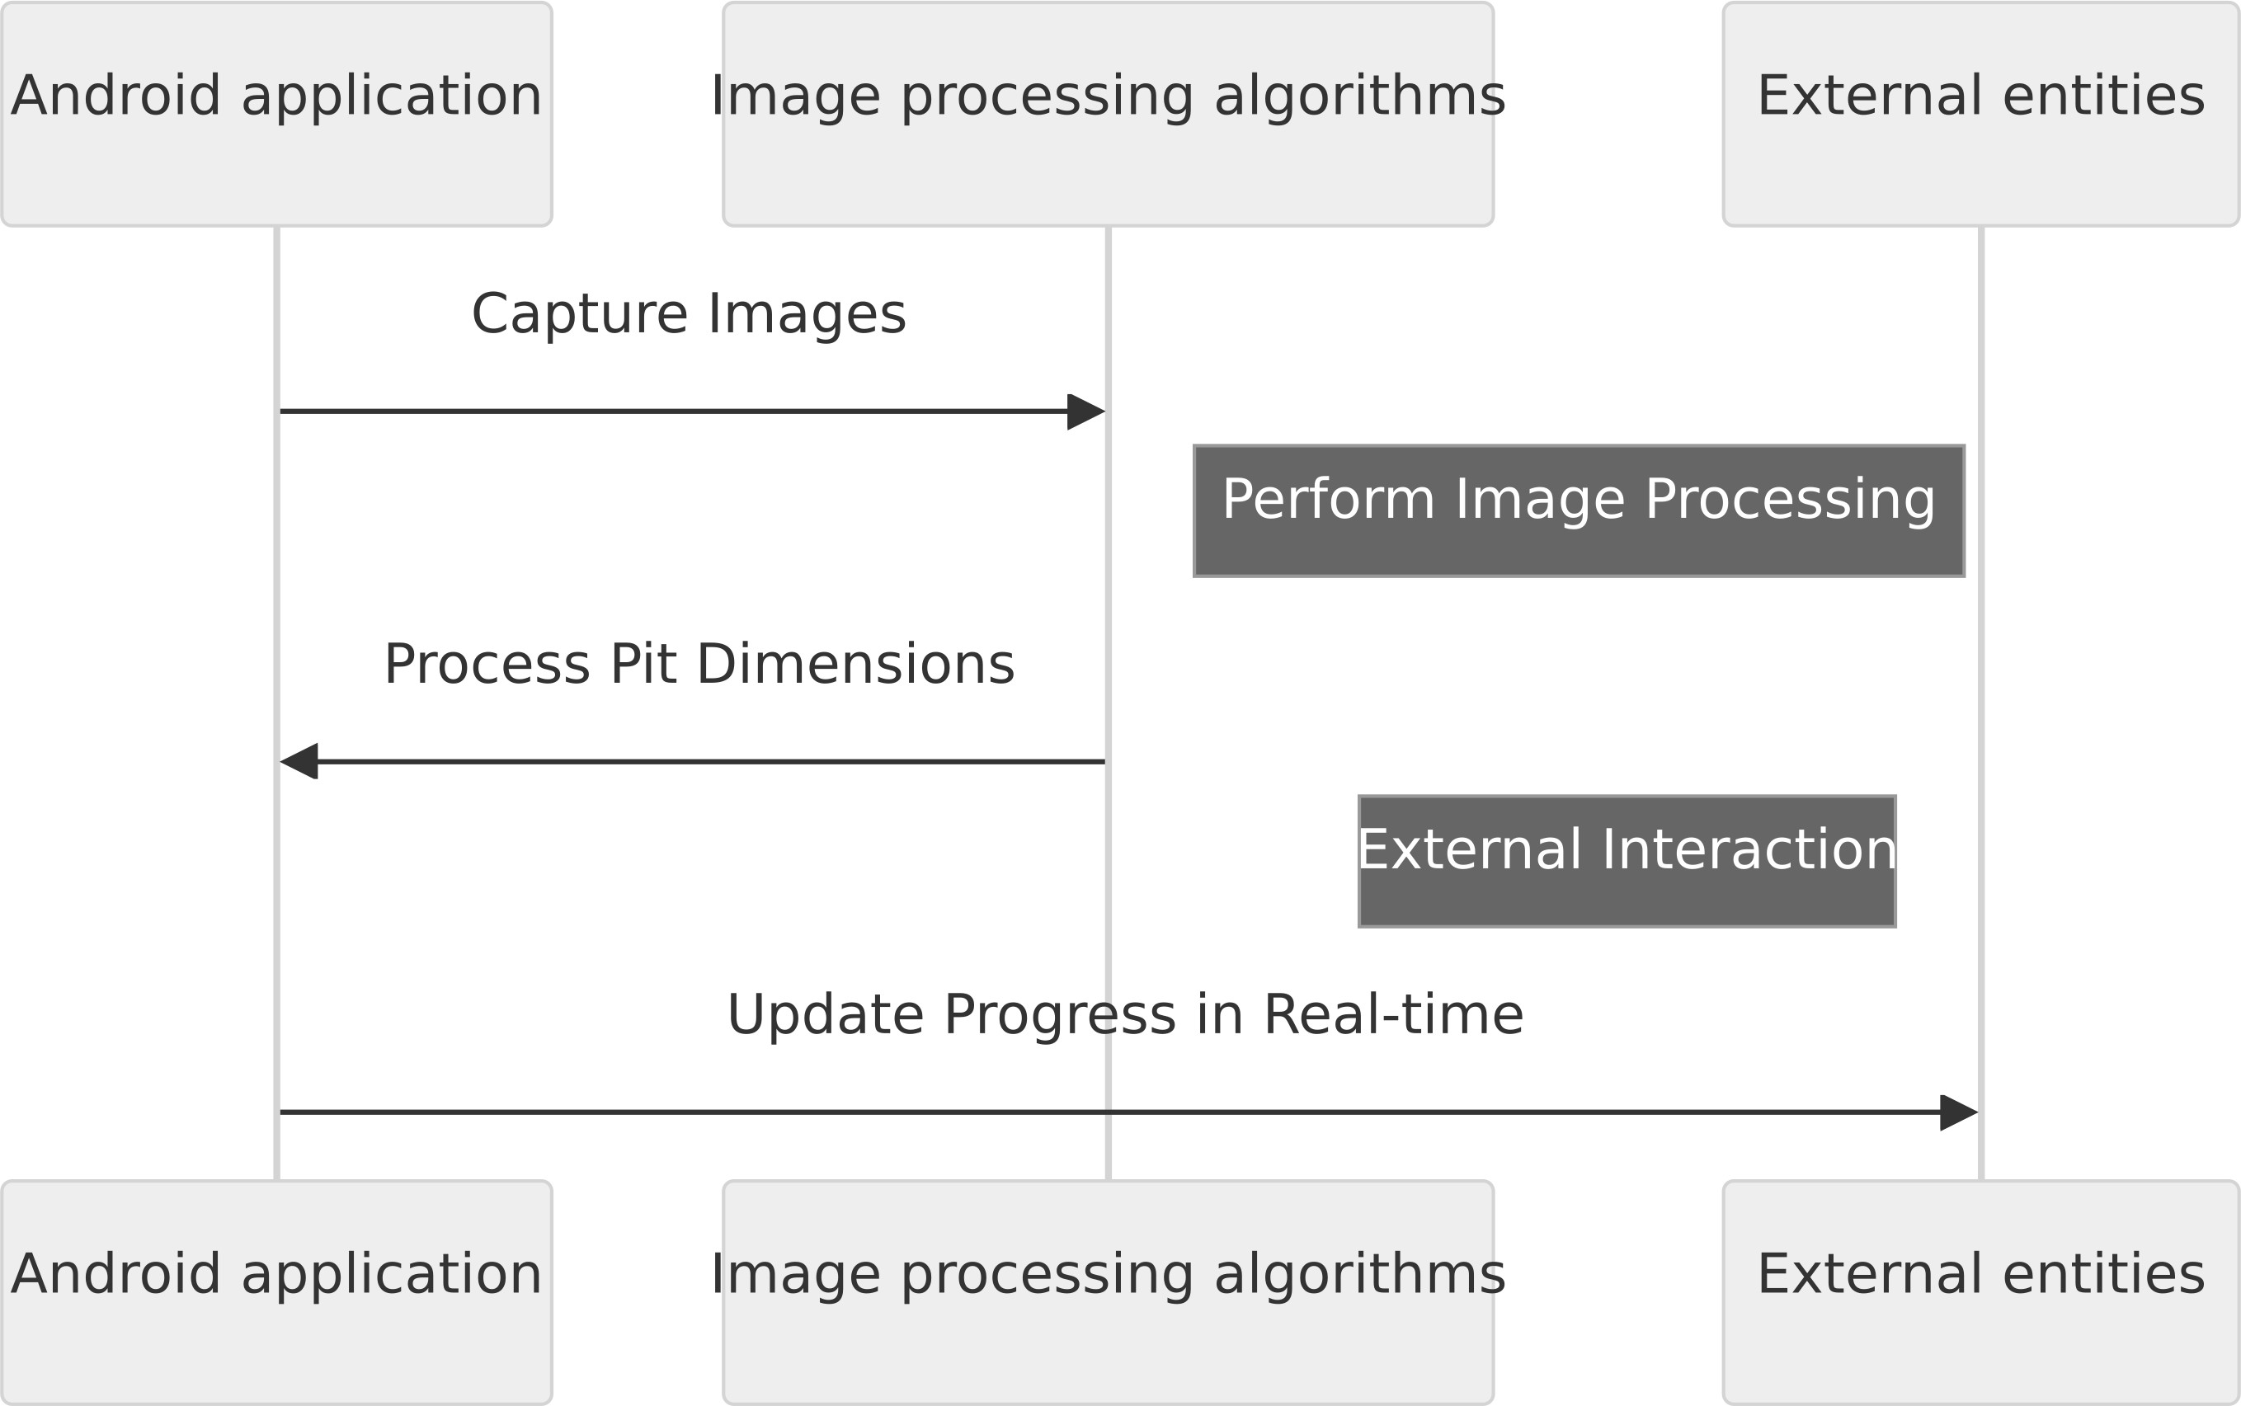

Figure 5.3: Sequence diagram of MGNREGA App

#### Activity Diagram

An activity diagram is a type of behavioral diagram in the UML that models the flow of activities in a system. It is a visual representation of the steps and decisions involved in a process, workflow, or use case, and is commonly used in software development, business process modeling, and project management.The data entered by the user will be sent to the database to confirm registration or login. Figure 5.4 represents the Activity diagram of the rural MGNREGA app.

The activity diagram for the Mahatma Gandhi National Rural Employment Guarantee Act (MGNREGA) image processing project delineates the dynamic workflow, highlighting key activities and interactions among project components. Initially, field workers initiate the image capture process through the Android ap- plication, activating the device camera to capture images of pit works. Following this, the system employs image processing algorithms to analyze captured im- ages, calculating pit dimensions accurately. If successful, the process advances to real-time progress monitoring, where administrators and field workers access the application to view current progress updates.

The system continuously collects user feedback, fostering a loop for iterative improvement. Users provide feedback on the application’s usability and accu- racy, and based on this input, improvements are implemented. Finally, ongoing activities in system maintenance involve regular monitoring, addressing reported issues, and implementing updates to accommodate evolving requirements. This horizontal-axis activity diagram offers a comprehensive visual representation of

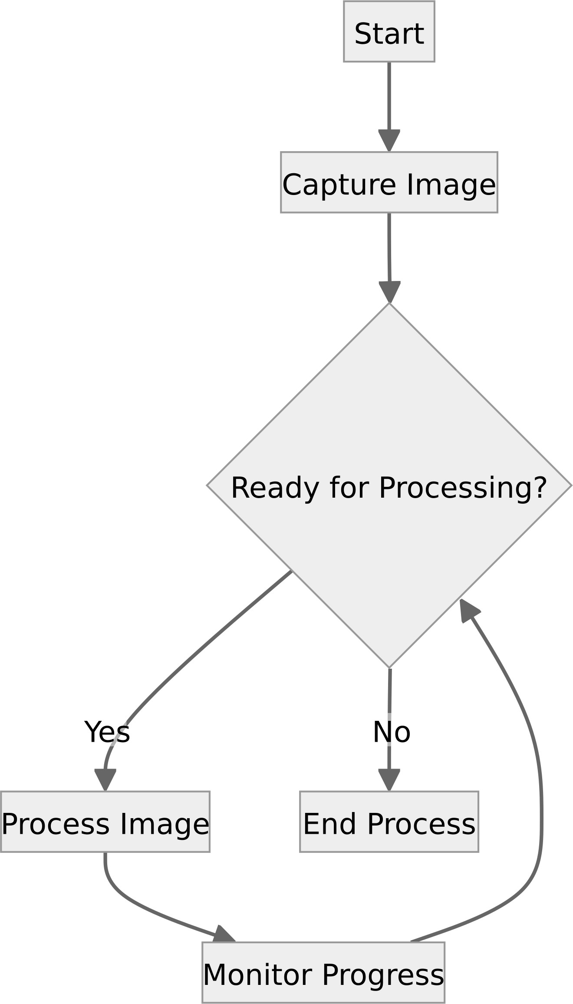

Figure 5.4: Activity diagram of MGNREGA App

the sequential flow of activities, facilitating a nuanced understanding of the opera- tional dynamics of the MGNREGA image processing project for stakeholders and developers.